Letter of Support – Canadian Ecology Centre
May 14, 2026
Friends of the Mining sector,
As Minister of Natural Resources under the Conservative Government of Mike Harris we launched the Lands for Life initiative, which saw the largest increase in parks and protected space in the history of the province. It laid the groundwork for the government's Living Legacy program, the single biggest expansion of parks in Ontario.
It was at this time I visited the CEC when the cabins were first being constructed. I could see the vision related to environmental education for students/teachers, NGO’s, First Nations and other organizations.
Retiring from politics I became the President and CEO of the Ontario Mining Association (20 years). It was then that Bill Steer, founder of the CEC concept, approached the OMA with the mining tours initiative. It was to bring more awareness to teachers and students about modern mining – occupations and the trades, safety, the environment and technology.
It has worked, and the OMA continues to fund the annual tours approaching 18 years. I would receive compelling letters from the tours’ participants. It has made a difference.
The CEC has stood the test of time for almost thirty years. The devastating storm of June 21, 2025, which ravaged Samuel de Champlain Provincial Park – closed the CEC down for almost one year.
The CEC needs help from the mining sector.
Please consider a donation.

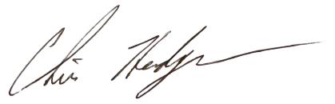
Sincerely,

Chris Hodgson
President/CEO
OMA (retired)
c.hodgson@rogers.com

